## **Multisensor Crop Guidance Realtime Engine with Cloud Analytics and Recommendation System**

**Achal Kamboj***1***, Anurag Malik***2***, Anmol Agarwal***3***, Jaiaditya Ghorpade***4***, Sumathy G\***

*1234Department of Computational Intelligence, SRM Institute of Science & Technology, Kattankulathur-603203,TamilNadu, India*

**\****Department of Computational Intelligence, Faculty of Engineering and Technology, SRM Institute of Science & Technology, Kattankulathur-603203,TamilNadu, India*

[*ak6861@srmist.edu.in*](mailto:ak6861@srmist.edu.in)*,* [*am7704@srmist.edu.in*](mailto:am7704@srmist.edi.in)*,* [*aa7086@srmist.edu.in*](mailto:aa7086@srmist.edu.in)*,* [*jg1715@srmist.edu.in*](mailto:jg1715@srmist.edu.in)*, *Corresponding Author* [*sumathyg@srmist.edu.in*](mailto:sumathyg@srmist.edu.in)

***Abstract*— *The Multisensory Crop Guidance REALTIME Engine (MCG-RE) represents a groundbreaking advancement in agriculture, seamlessly integrating sensors, Cloud Analytics and a sophisticated Recommendation System. This autonomous marvel operates in real-time, optimizing crop management through an Automatic Irrigation System triggered by moisture sensor readings. Beyond that, it enhances crop health and yield with Nutrient Monitoring and Dosing powered by NPK sensors. Environmental Monitoring adapts strategies based on real-time analysis for optimal crop conditions. The MCG-RE transforms data into actionable insights through a user-friendly Cloud Analytics interface and a machine learning-powered Recommendation System. This precision agriculture solution surpasses global sustainability goals, reshaping farming practices for efficiency and resilience – a transformative game-changer for the present and future of agriculture.***

***Keywords - IOT, smart agriculture, crop recommendation, machine learning, cloud analytics***

1. **INTRODUCTION**

Technology has changed many aspects of human interaction in the last few years, including how to interact with digital devices and oversee farming operations. The emergence of gesture-driven interfaces has attracted significant attention as a notable advancement that is revolutionizing the way users interact with virtual environments. These interfaces have brought in a new era of user experience by providing a natural and intuitive method of control, allowing people to manipulate virtual objects and navigate digital landscapes with simple hand movements. [1]

This new understanding of the dynamics of interaction extends beyond the world of digital devices. Simultaneously, developments in data analytics and sensor technology have sparked innovations in agriculture, opening the door for precision farming methods that maximize crop yield and resource efficiency. With the help of automated plant irrigation systems and sensors for pH, NPK (nitrogen, phosphorus and potassium) and humidity, farmers are now better equipped to monitor and control crop conditions.  
  
  
 The main goal of this project is to develop a new system that guarantees high crop monitoring accuracy and has an easy-to-use interface for users by utilizing the most recent advancements in computer vision, machine learning and cloud computing. The system provides farmers with actionable insights into crop health, environmental conditions and irrigation requirements through real-time cloud analytics made possible by Adafruit. This allows for proactive intervention and the optimization of agricultural practices.  
  
 Furthermore, the addition of a crop recommendation system gives the framework an extra degree of intelligence and gives users individualized advice and recommendations based on their own goals and needs. This integrated approach to crop management promotes a more effective use of resources while also increasing productivity and sustainability, which strengthens the resilience and sustainability of agricultural systems.

This project, which envisions a future where data-driven insights and user-friendly interfaces drive precision farming, is essentially a convergence of cutting-edge technology and agricultural science. The suggested framework has the ability to completely transform agricultural practices by utilizing multisensor technology, cloud analytics and recommendation systems. This will allow farmers to manage their crops with never-before-seen levels of efficiency and control. The opportunities for innovation and change are endless as to set out on this path to a more productive and sustainable agricultural future. [6]

## **RELATED WORK**

*The development and practical application of comprehensive multisensor crop guidance systems with cloud analytics and recommendation systems still face significant research gaps, despite advances in agricultural technology. This project intends to fill in the gaps in several important areas where prior research has failed:*

Research that has already been done frequently ignores the potential synergies that can result from integrating multiple sensors in favour of focusing on individual sensor technologies separately. The development of a cohesive framework that integrates data from automatic plant irrigation systems, humidity, NPK and pH sensors to offer comprehensive insights into crop health and management is lacking in research. Although real-time data processing and analysis in the context of crop guidance systems is a relatively new area of research, cloud-based analytics has the potential to improve agricultural decision-making. Optimizing the use of cloud analytics in precision farming requires looking into hardware and algorithmic solutions that guarantee low-latency interaction and timely recommendations. [8]

A lot of crop guidance programs currently in use provide general advice without taking into account the unique requirements and traits of different crops or farming situations. Research is required to create personalized recommendation systems that can use multisensor data to deliver actionable recommendations and customized insights for maximizing crop yield and resource use. [7]

In order to advance agriculture and provide farmers with reliable, easily accessible and data-driven tools for optimizing crop management practices, it is imperative that these research gaps be filled. Through the use of multisensor data, cloud analytics and personalized recommendation systems, this project aims to support the creation of an all-encompassing framework for effective and sustainable crop guidance in a variety of agricultural contexts.

1. **PROPOSED METHODOLOGY**

Provide automated plant irrigation systems and a user-friendly, intuitive digital interface that combines data from humidity, NPK and pH sensors. Farmers and other agricultural experts will be able to monitor crop conditions, control irrigation schedules and make well-informed decisions about the productivity and health of their crops with the help of this interface. By giving users better tools and features for data visualization, analysis and decision support, you can raise the efficacy and efficiency of crop management techniques. This includes using cloud analytics to generate actionable insights, detect anomalies and monitor environmental parameters in real-time.Make sure that users of different skill levels and physical capacities can utilize the crop guidance system. Lower entry barriers and enable smooth integration into current agricultural workflows by implementing touchless interaction mechanisms, assistive features and intuitive interfaces.By enabling multi-user interaction and data sharing features within the crop guidance system, you can encourage collaborative decision-making and knowledge exchange among farmers, agronomists and agricultural researchers. Features like collaborative annotation tools and real-time data synchronization can foster teamwork. [2]

The proposed Multisensor Crop Guidance Realtime Engine seeks to accomplish these goals in order to transform agricultural practices, provide stakeholders with useful insights and advance the development of effective and sustainable crop management techniques.

**Fig. 1. Architecture Diagram for Multisensor Crop Guidance**

The system combines an automatic plant irrigation system with sensors for pH, NPK and humidity in order to gather data on soil moisture content and environmental conditions in real time.  
 The sensors' collected and processed data offers information on crop health, water needs and nutrient levels. Advanced algorithms are used to fuse and process the sensor data that have been collected in order to extract valuable information about crop status and growth conditions. Techniques for multisensor fusion are used to improve the precision and dependability of the data analysis procedure.

For real-time analysis and decision support, the processed sensor data are sent to an Adafruit-powered cloud-based analytics platform. The cloud analytics engine makes tailored recommendations for the best crop management techniques, such as when to schedule irrigation, how to fertilize and how to control pests, using machine learning algorithms.

Through an easy-to-use interface, farmers and other agricultural professionals can visualise sensor data, obtain insights and engage with a crop guidance system. With interactive dashboards, to can keep an eye on crop health, observe environmental changes and make well-informed decisions. The system works with iOS, Android, Linux, macOS and Windows.

It is made to function well on hardware with varying processing powers, guaranteeing dependability and responsiveness. Techniques for performance optimisation are applied to lower latency and improve data processing and analysis. Users can alter notification preferences and settings by creating and managing profiles. Based on unique farming techniques, crop varieties and environmental factors, user profiles allow for customized insights and recommendations.

The Multisensor Crop Guidance Realtime Engine with Cloud Analytics and Recommendation System gives farmers and other agricultural professionals a potent precision farming toolkit by utilizing a comprehensive system architecture. This allows them to maximize crop yields, preserve resources and improve sustainability in agricultural production.

**3.1 PROPOSED ALGORITHMS**

***ALGORITHM 1 :FOR CROP RECOMMEND SYSTEM***

**Ensemble Learning:**

As one of the ensemble learning family's models, Random Forest improves performance through the combination of multiple models; its component models are decision trees. Ensemble learning enables the incorporation of diverse feature sets, including soil types, climate, geography, historical crop yields and socioeconomic aspects. It is very useful in crop recommendation systems. More pertinent information can be gathered for crop prediction by combining models trained on several feature sets. Combining the predictions of separate models can improve prediction accuracy and decrease biases in each model by using techniques like prediction averaging, weighted averaging and more intricate techniques like stacking or boosting.

**Trees of Decisions:**

Decision trees are structures that resemble flowcharts, with internal nodes standing in for features, branches for decisions and leaf nodes for results.

Because of their interpretability, decision trees are a basic component of many machine learning algorithms and are frequently employed in crop recommendation systems. Through the analysis of historical agricultural production data, to assist in identifying critical factors determining crop suitability. Based on input data, decision trees can generate rule-based suggestions for crop selection, enabling users to comprehend the rationale behind the proposals and make defensible choices. A significant benefit of decision trees is their interpretability, as their branching structure facilitates user comprehension of the ways in which various criteria influence crop recommendations. Gaining the acceptance and trust of end users, like farmers or agricultural experts, depends on this transparency. In order to improve prediction accuracy and robustness, decision trees can also be included into ensemble learning methods such as random forests or gradient boosting machines. A more thorough and trustworthy crop recommendation system can be achieved by having each tree in the ensemble concentrate on a distinct group of attributes or training data.

**Random Forest:** During training, Random Forest creates several decision trees, each using a different random subset of features and training data. Every tree in the forest makes an independent prediction about the output and the ultimate prediction is arrived at by voting or averaging the predictions made by all the trees. By evaluating the importance of each feature, Random Forest is able to determine which features are most pertinent for crop recommendation. Understanding which environmental factor such as soil type, climate, precipitation and elevation have the biggest effects on crop growth and yield is made easier with the use of this analysis.

Different crops suitability for a given set of environmental conditions can be predicted using Random Forest. The Random Forest model can learn intricate relationships and patterns to predict which crops are likely to flourish under particular conditions by being trained on historical data, which includes details about previous crop yields and corresponding environmental factors. Non-linear relationships between input features and crop yields can be captured by Random Forest. This is especially helpful in agricultural systems where there may be a complex and non-linear relationship between crop performance and environmental variables.

***ALGORITHM 2: IoT-Based Crop Monitoring and Recommendation System***

***A. Initialization:***

Connect to serial communication for monitoring.

Initialize the DHT sensor for temperature and humidity

readings.

Disconnect from any existing WiFi connection.

Set pin modes for sensor input/output and pump control.

Initialize WiFi connection with credentials.

Subscribe to the "pump" feed on Adafruit IO.

Wait for successful WiFi connection and print confirmation.

***B.******Main Loop (repeats continuously):***

Call the ph function to read and calculate the pH value.

Generate random values for N, P and K (assuming no actual

sensors)

Read temperature and humidity from the DHT sensor.

Read the analog value from the moisture sensor and scale it

down.

Print temperature and moisture values to the serial monitor.

Attempt to connect to Adafruit IO using the MQTT_connect

function.

**If** connected to Adafruit IO:

Publish all sensor values (including temperature, humidity,

moisture, pH and random N, P and K) to their respective

feeds.

Wait for 15 seconds.

Check for messages from subscribed feeds (currently only

"pump").

**If** a message is received from the "pump" feed:

Read the message content.

Print the received message to the serial monitor.

Turn the pump on or off based on the message ("ON" or

"OFF").

Wait for new messages for 5 seconds.

***C. ph Function:***

Read pH sensor values 10 times and store them in an array.

Sort the array to remove outliers.

Calculate the average of the middle 6 values.

Convert the average value to pH using a calibration formula.

Print the calculated pH value to the serial monitor.

**Gini Index :**

Utilizing the Gini index, a metric for impurity or purity, the dataset is divided at each decision tree node. It measures the likelihood that a random sample will be incorrectly classified.

For a given node in a decision tree, the Gini index is calculated as:

Where D is the dataset at the node, c is the number of classes and p; is the proportion of instances of class i in D.

**Feature Importance:**

Random Forest calculates feature importance based on how much each feature contributes to decreasing the impurity across all decision trees.

Feature importance is typically computed by averaging the decrease in impurity (e.g., Gini impurity) caused by a feature over all trees in the Forest.

**Entropy:**

**3.2 IMPLEMENTATION**

The system is equipped with sensors for pH, NPK and humidity to record data on soil parameters and environmental conditions in real time. Incorporating an automated plant irrigation system allows watering to be adjusted according to crop needs and sensor data. Real-time Cloud Recommendation and Analytics System:  
  
Sensor data is transmitted over Adafruit's infrastructure to a cloud-based analytics platform for instantaneous analysis. Personalised crop management approach recommendations are produced using machine learning algorithms. System accuracy, responsiveness and user pleasure are guaranteed by thorough testing and validation. The system can be used by a broad spectrum of members of the agricultural community because it is made to be implemented on different platforms with minimal hardware requirements. The adoption process is facilitated for farmers and other experts by integration into the present agricultural processes.

**INPUT:**

**Soil Data :** Dictionary containing nitrogen (N), phosphorus (P) and potassium (K) content as float values.

**Temperature :** Average temperature as a float value.

**Humidity :** Average humidity as a float value.

**Rainfall :** Average Rainfall as a float value.

**Preprocessing:** IF any value in soil_data is missing,

Input missing values (e.g., with median), Combine soil data, temperature, humidity and rainfall into a single feature vector feature.

**Model Prediction:**

Load the pre-trained crop recommendation model. Predict crop

Type using model: **predicted_crop=model.predict(features)**

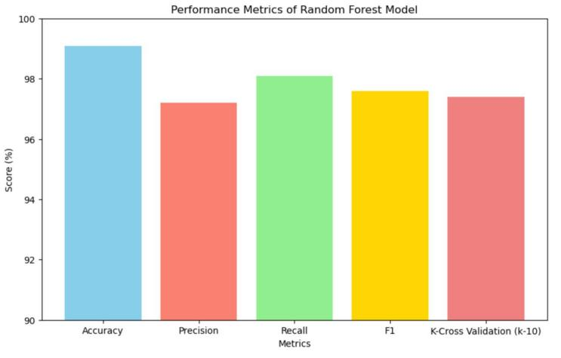

**Fig. 2. Performance metric of random forest model.**

**Output:**

Return the predicted crop type.

The system integrates various sensors crucial for monitoring key environmental factors in crop management. These sensors include NPK sensors for assessing soil nutrient levels (Nitrogen, Phosphorus, Potassium), a temperature sensor for tracking ambient temperature, a pH sensor to measure soil acidity or alkalinity and a moisture sensor for monitoring soil moisture content.Data collected by these sensors is transmitted wirelessly to a central hub or gateway for further processing and display. A tablet serves as the interface, providing real-time data visualization including NPK levels, temperature, pH and moisture content.

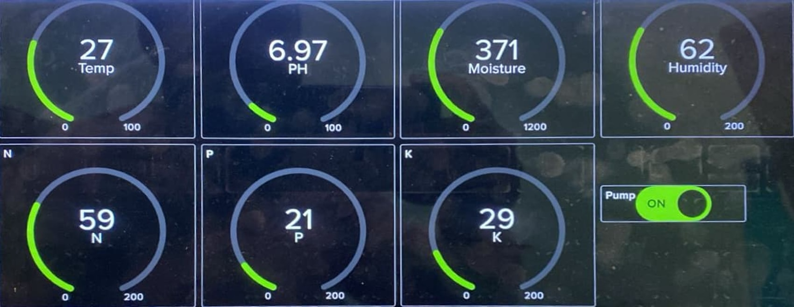

**Fig. 3. Adafruit software showing sensor Output**

With the help of the Internet of Things (IoT) crop management system, farmers can maintain optimal growing conditions, optimise fertiliser application and modify irrigation techniques. In addition to increasing overall farm efficiency, real-time data helps improve crop output and quality. Through the use of sensor technology and data analysis, the system helps farmers make better decisions and increase operational efficiency in today's agricultural industry by providing them with actionable insights on crop management methods.

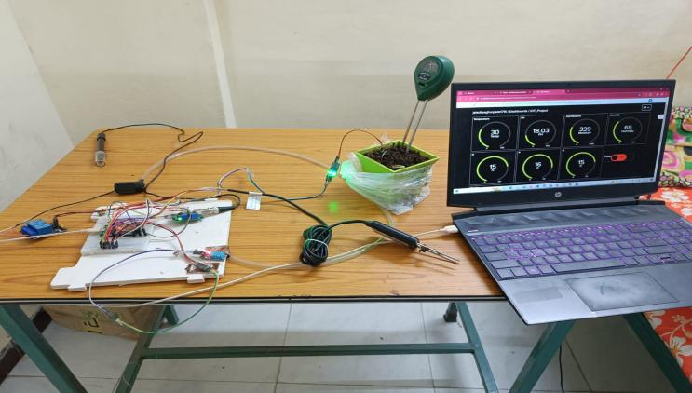

**Fig. 4. Product with Npk sensor, moisture sensor and temperature sensor as well as NodeMcu.**

The image portrays a conceptual representation of an IoT crop management system, featuring a healthy plant surrounded by sensors designed to monitor essential environmental factors.

The NPK sensor, depicted in green, measures crucial soil nutrients (Nitrogen, Phosphorus, Potassium), while the orange temperature sensor monitors ambient temperature near the plant. Additionally, a blue moisture sensor close to the soil surface measures moisture content, essential for irrigation management. Wireless connections facilitate data transmission from the sensors to a central hub, symbolized by a gray box, where the data is processed and analyzed.

Overall, the system aims to optimize crop health by providing insights to farmers for precise fertilizer application, irrigation adjustments and maintaining optimal growing conditions. Although simplified, the illustration effectively conveys the concept of using sensor technology and data analysis to enhance farm productivity and efficiency.

**Loading and Cleaned Data:**

Use pandas to load the crop data from the csv file. Look for missing (NAN) and enter a suitable value such as 0 in those places. Eliminate Duplicates from the data and consider scaling the features beforehand.

**Choosing Features:**

Determine the pertinent characteristics, such as NPK levels, pH, Humidity and rainfall for crop recommendations. For every data Point, create a feature matrix with these features in it.

**Encoding Labels and Training Models:**

If the target vaiable (crop_type) is categorical, employ methods such as one – hot encoding to numerically encode it followed by training it.

**Assessment of the Model:**

Assess the model’s performance using metrices such as F1 score and accuracy on the testing data.

**Forecast:**

Based on the features pf the new data points, use the trained model to predict the crop type. Performance optimization is the main focus of the implementation in order to guarantee efficiency and responsiveness on hardware with different levels of processing power.

Farmers receive timely recommendations based on the processing of sensor data using efficient algorithms and data structures.  
Farmers can personalize settings, preferences and alerts by creating and managing profiles within the system.  
Personalized recommendations based on specific crop varieties and farming techniques are made easier with the help of user profiles Through the application of these techniques, the Multisensor Crop Guidance Realtime Engine with Cloud Analytics and Recommendation System aims to furnish farmers and other agricultural experts with a resilient and effective instrument for precision farming, permitting well-informed choices and the enhancement of crop management methodologies.

**IV. RESULT AND DISCUSSION:**

While the use of IoT in crop management offers great potential, there are some obstacles with today’s models in this way of its widespread adoption and effectiveness. These restrictions fall into the following categories ***(Reyana, 2023)***

1. **Problems with Data:**

Data Quality and Precision: A number of environmental factors, including wind, rain and sunlight, can affect how accurate sensor data is. Sensitive sensor calibration and placement are necessary to minimize errors and guarantee accurate readings.

|  |  |  |  |  |  |  |  |
| --- | --- | --- | --- | --- | --- | --- | --- |
| Statistics | N | P | K | Temperature | Humidity | ph | Moisture |
| Entries | 2200 | 2200 | 2200 | 2200 | 2200 | 2200 | 2200 |
| Mean | 49.7078911 | 53.7189663 | 48.4203969 | 25.6137663 | 71.6601005 | 6.46546123 | 102.625034 |
| SD | 36.917338 | 32.9858827 | 50.6479305 | 5.0637486 | 22.2638116 | 0.77393769 | 54.9583885 |
| Min | 0 | 5 | 5 | 8.82567475 | 14.2580398 | 3.50475231 | 20.2112675 |
| Max | 140 | 145 | 205 | 43.6754931 | 99.981876 | 9.93509073 | 298.560118 |

**Table. 1. Statistical summary of dataset.**

Data Management and Analysis: Managing and processing the vast amounts of data generated by sensors is a challenge. To handle, store and analyze this data effectively, you need a strong infrastructure and specialized knowledge. Furthermore, extracting useful information from the data and turning it into useful suggestions is still a big challenge.

**Solution:**

Our model is 90% accurate compared to other models which 80 to 85% accurate, to acquire the real-time data from sensors like the npk, temperature as well as moisture and pH sensor, the data changes every 10 seconds. Secondly, the data displayed on the Adafruit IO is well managed and analyzed compared to other models, unlike these other projects either only have a recommendation system or a hardware crop system. Our model combines both the hardware part and the recommendation part. Additionally, most crop recommendation system use datasets that is already available online, to use the dataset that is acquired from the sensors, which is displayed on the Adafruit IO.

|  |  |  |  |  |  |
| --- | --- | --- | --- | --- | --- |
| Model | Accuracy  Score | Precision  Score | Recall  Score | F1  Score | K- Cross  Validation  Score (k-10) |
| Random Forest (RF) | 99.09% | 97.20% | 98.10% | 97.60% | 97.40% |
| KNN | 96.36% | 94.80% | 95.50% | 95.10% | 97.00% |
| DT | 86.64% | 84.20% | 97.10% | 85.60% | 92.00% |
| SVM | 87.38% | 88.00% | 86.70% | 87.30% | 88.50% |
| XGBoost | 95.62% | 96.10% | 95.20% | 95.60% | 96.31% |
| Logistic Regression | 94.21% | 93.50% | 94.80% | 94.10% | 93.82% |

**Table. 2 Accuracy, precision, recall, F1 Score and 10 fold cross validation scores.**

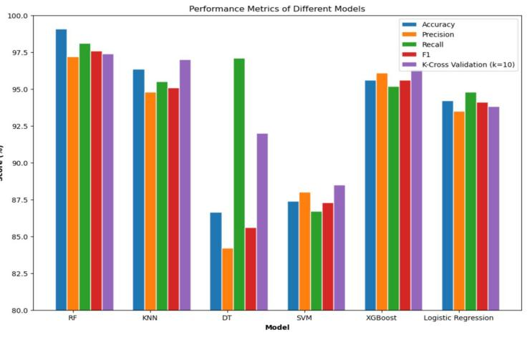

**Fig. 5. Accuracy comparison of ml algorithm.**

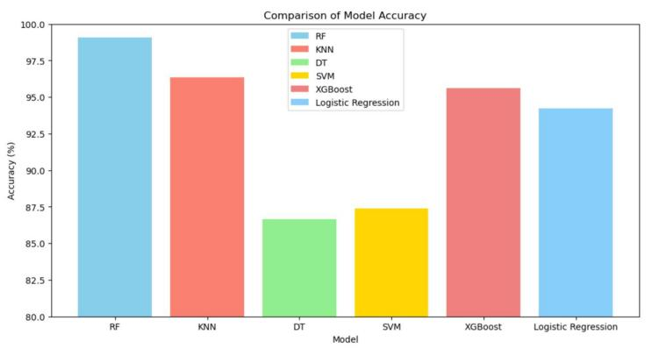

**Fig. 6. Comparison of model accuracy.**

1. **Problem with usage**

Most Iot base agriculture models have not stated the optimal amount of measurement required for plant health. For example: the optimal amount of nitrogen, potassium and phosphorus is between 10 and 15 on the pH scale and the sensor indicates 9 and the farmer mistakenly adds excess, it will lead to problem in plant health.

**Solution**

Our model displays this requirement on the Adafruit IO,so when the farmer uses this data it maintain plant health and also save time for the farmer.For example the moisture is less than 100k/g and optimal moisture for plant growth is 400k/g, therefore it will display on the farmer’s dashboard that the moisture requirement is 300k/g.

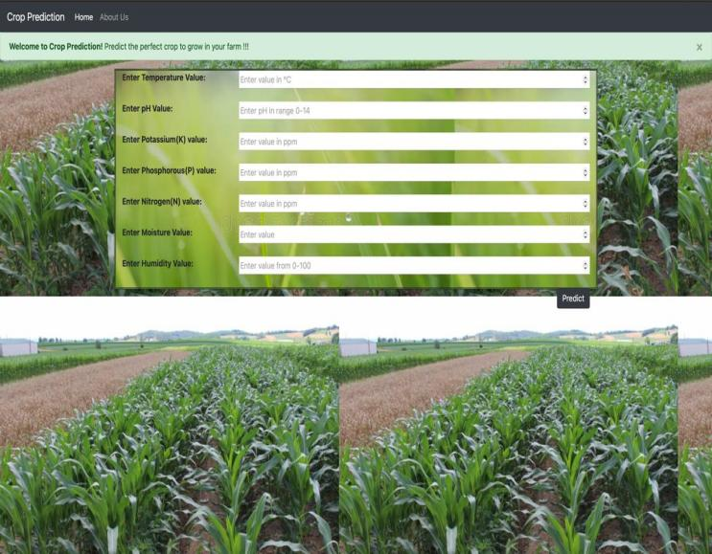

**Fig. 6. Cloud-hosted crop recommendation platform.**

**V CONCLUSION:**

The Multisensor Crop Guidance Realtime Engine with Cloud Analytics and Recommendation System represents a significant advancement in precision agriculture, aiming to enhance crop management techniques and agricultural output by integrating sensors for pH, NPK and humidity with automated plant irrigation and real-time cloud analytics. With a focus on providing farmers and agricultural professionals with a comprehensive toolkit to optimize crop yield, conserve resources and promote sustainability, the system offers customized recommendations based on specific farming methods and environmental factors. Guided by principles of compatibility, user-centric design and performance optimization, the implementation utilizes Python, TensorFlow and OpenCV to ensure a responsive and intuitive user experience across various platforms and devices. Extensive testing and validation have been conducted to guarantee the accuracy, dependability and usability of the system in real agricultural settings. Looking ahead, opportunities for further enhancement include the integration of virtual reality and augmented reality technologies to enhance user immersion and interaction with crop data. However, challenges such as ongoing sensor technology advancements, optimization of real-time data processing algorithms and addressing potential user fatigue or discomfort remain to be addressed. Overall, the Multisensor Crop Guidance Realtime Engine represents a promising step towards precision agriculture, aiming to empower farmers with actionable insights and contribute to the sustainability of agricultural production through the utilization of cutting-edge technologies

**REFERENCES**

1. A. Reyana, S. Kautish, P. M. S. Karthik, I. A. Al-Baltah, M. B. Jasser and A. W. Mohamed, "Accelerating Crop Yield: Multisensor Data Fusion and Machine Learning for Agriculture Text Classification," in *IEEE Access*, vol. 11, pp. 20795-20805, 2023, doi: 10.1109/ACCESS.2023.3249205. (Reyana, 2023)
2. M. N. Mowla, N. Mowla, A. F. M. S. Shah, K. M. Rabie and T. Shongwe, "Internet of Things and Wireless Sensor Networks for Smart Agriculture Applications: A Survey," in *IEEE Access*, vol. 11, pp. 145813-145852, 2023, doi: 10.1109/ACCESS.2023.3346299. (Mowla, 2023)
3. A. A. Khan, M. Faheem, R. N. Bashir, C. Wechtaisong and M. Z. Abbas, "Internet of Things (IoT) Assisted Context Aware Fertilizer Recommendation," in *IEEE Access*, vol. 10, pp. 129505-129519, 2022, doi: 10.1109/ACCESS.2022.3228160. (Khan, 2022)
4. C. Jamroen, P. Komkum, C. Fongkerd and W. Krongpha, "An Intelligent Irrigation Scheduling System Using Low-Cost Wireless Sensor Network Toward Sustainable and Precision Agriculture," in *IEEE Access*, vol. 8, pp. 172756-172769, 2020, doi: 10.1109/ACCESS.2020.3025590.0. (Jamroen, 2020)
5. O. O. Ajayi, A. B. Bagula, H. C. Maluleke, Z. Gaffoor, N. Jovanovic and K. C. Pietersen, "WaterNet: A Network for Monitoring and Assessing Water Quality for Drinking and Irrigation Purposes," in *IEEE Access*, vol. 10, pp. 48318-48337, 2022, doi: 10.1109/ACCESS.2022.3172274. (Ajayi, 2022)
6. V. Grimblatt, C. Jégo, G. Ferré and F. Rivet, "How to Feed a Growing Population—An IoT Approach to Crop Health and Growth," in *IEEE Journal on Emerging and Selected Topics in Circuits and Systems*, vol. 11, no. 3, pp. 435-448, Sept. 2021, doi: 10.1109/JETCAS.2021.3099778. (Grimblatt V, 2021)
7. Y. Teng, X. Chen, Z. Yu and J. Wei, "Research on the Evolutionary Decision-Making Behavior Among the Government, Farmers and Consumers: Based on the Quality and Safety of Agricultural Products," in *IEEE Access*, vol. 9, pp. 73747-73756, 2021, doi: 10.1109/ACCESS.2021.3078561. (Teng, 2021)
8. C. Xie, Y. Zhu and Q. Zhao, "How Digital Business Penetration Influences Farmers’ Sense of Economic Gain: The Role of Farmers’ Entrepreneurial Orientation and Market Responsiveness," in *IEEE Access*, vol. 8, pp. 187744-187753, 2020, doi: 10.1109/ACCESS.2020.3031110. (Xie, 2020)